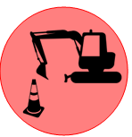
27TH AVENUE RAIL CROSSING UPGRADE

PROJECT #2025-07
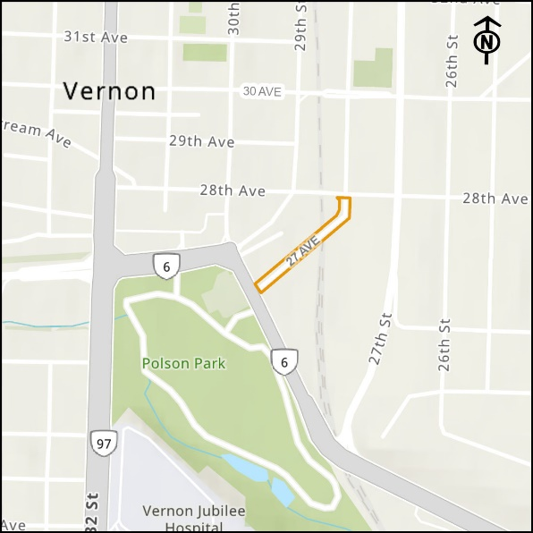
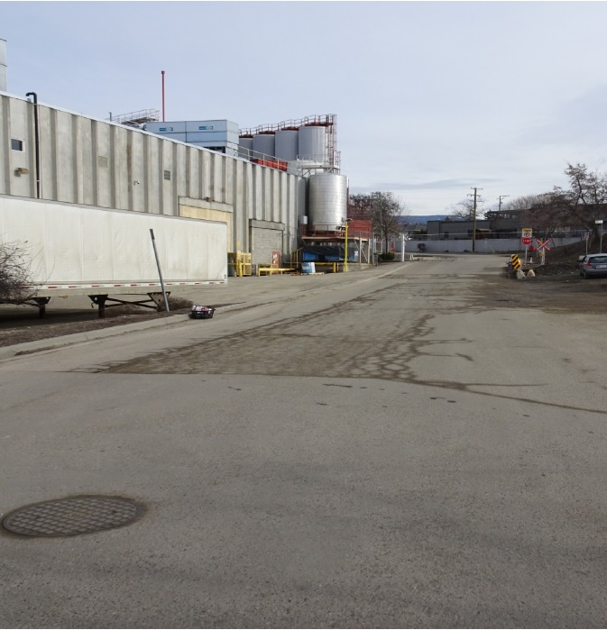

Total Capital Costs: $ 1,750,000
Operation and Maintenance Estimated Yearly Costs: $ 1,000

Project Summary

The project is required in order to comply with federal railway grade crossing regulations. The work includes the rehabilitation of the rail crossing surface, approximately 230 m of road, and 200 m of sanitary sewer replacement along 27th Avenue from Highway 6 to 28th Avenue. The project also includes new curb and sidewalk, as identified in the Master Transportation Plan.

